Product Management System.

## Overview :

This system is designed to allow the user to add/edit/delete and view a list of product inventory. Furthermore, products can also be imported into the system , via an excel spreadsheet which must conform to the following format.

i.e

|  |  |
| --- | --- |
| **Field** | **DataType** |
| Name | String |
| Description | String |
| CategoryName | String |
| CategoryId | Integer |
| Image | String |
|  |  |

Figure 1 - Table Excel Import

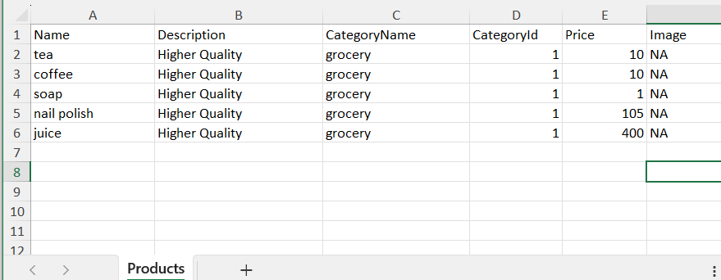

Figure 2- sample spreadsheet

Once logged into the system, you may click on the products menu item on the top menu bar. This will navigate you to the product listing page . On this listing page there are various options that allow you to do the following :

* View a list of all products
* Add a new product
* Edit / Update an existing product
* Upload an excel spreadsheet
* Download all products

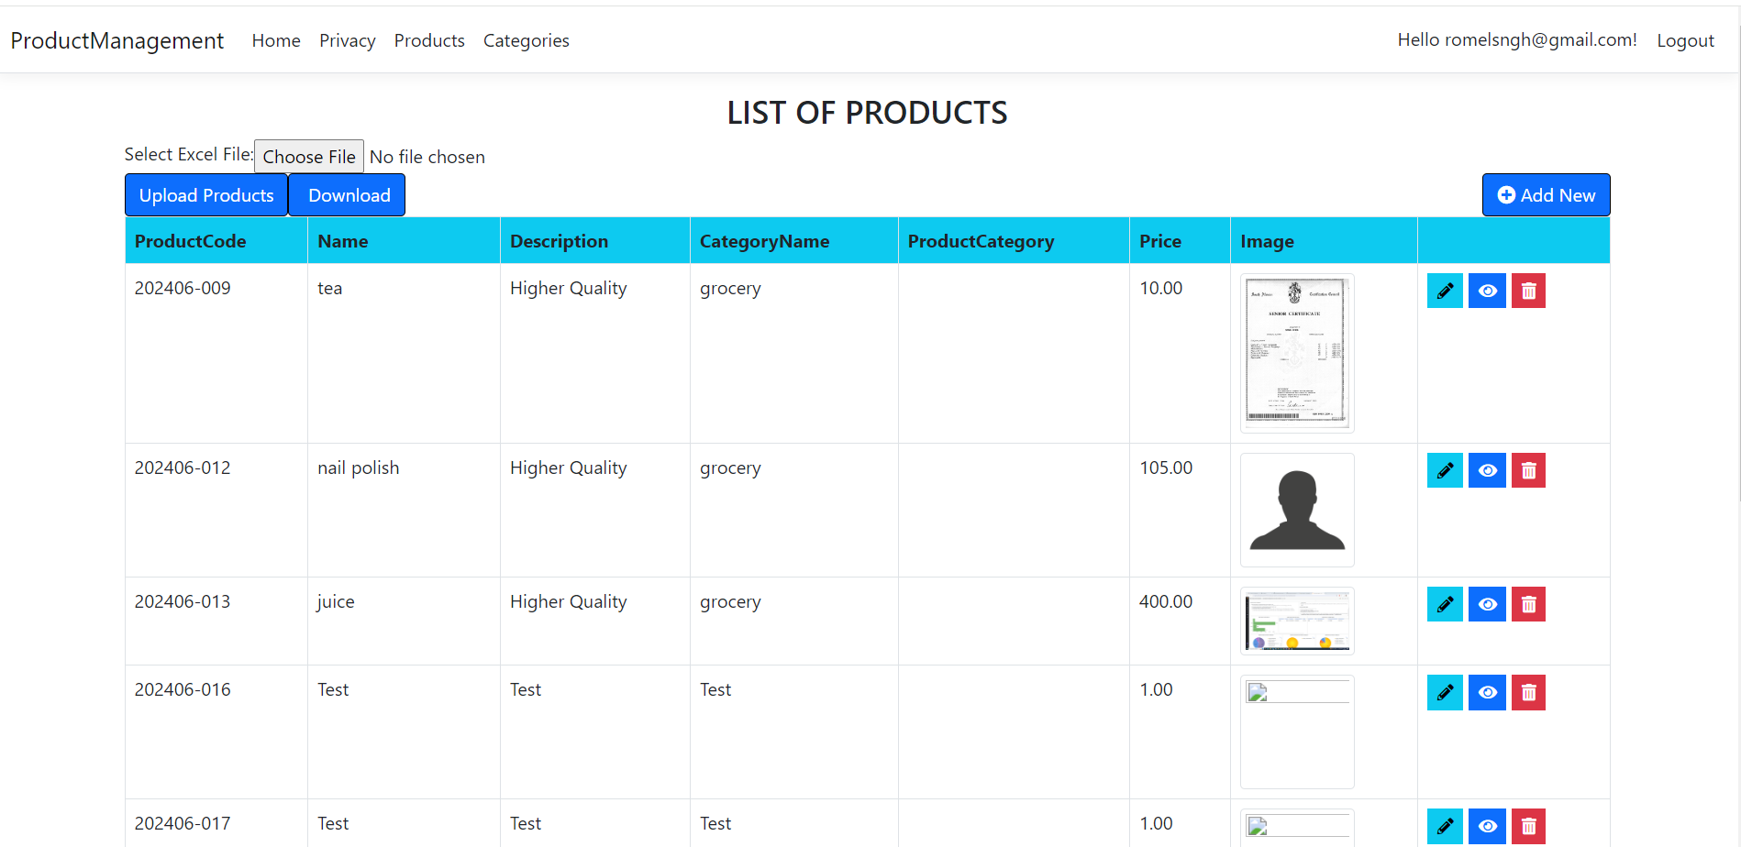

Figure 3 - Product List

## Homepage:

This is the landing page, with a few options to enter the system .

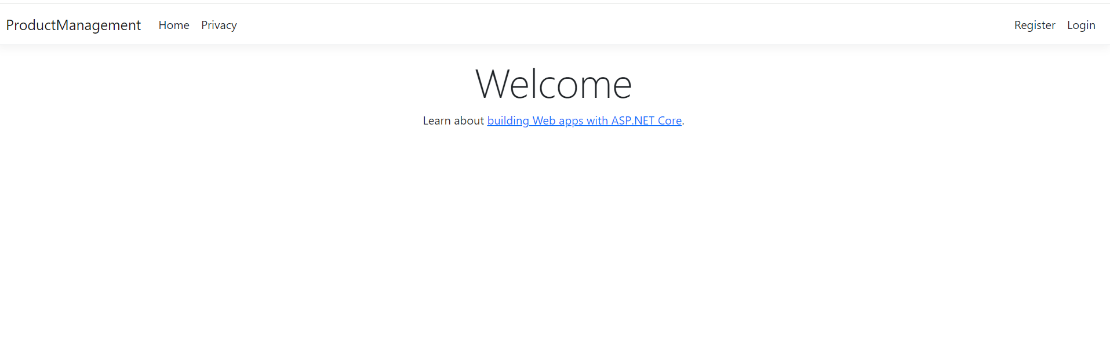

Figure 4 – Homepage

## Login Screen:

To login into the system, click on the login link on the top right hand side of the screen. It will then take you to the following screen. If you have not used the system, you will be required to register . as a user. This can be achieved by simply clicking on the “Register a new user” link below. Your will be required to register with an email address and a password of your choice.

Figure 5 - Login

Once you have completed the user registration process you may then login into the system using the newly created credentials. Once logged in, the following two menu options become available.

Figure 6 - Menu Options

To start using the system , you may proceed by clicking on the Categories menu.

## 

## Categories:

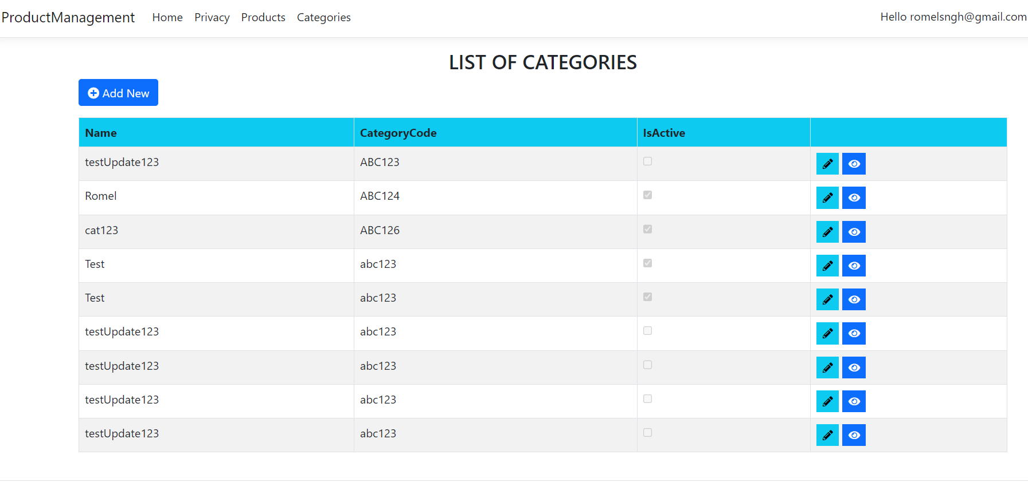

Figure 7 - Categories

Above is the category list screen. From this point of entry the user is allowed to create and edit category data.

**Edit Category :**

i.e User may click on the pencil icon on the right hand side of the list. This will take you into the Edit Category screen were you will be able to update information for the selected category.

Figure 8 - Edit Category

Once you are done updating the category details , please click on the update button. This will save the information.

**Create Category :**

This is a simple operation that can be accomplished by clicking on the “Add New” button.

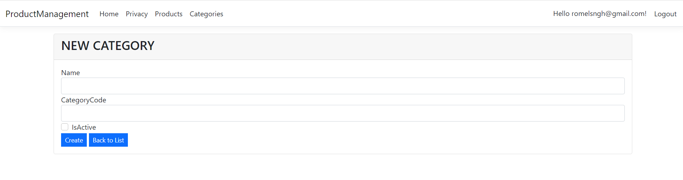

Figure 9 - Create Category

Simply enter in the new category details and click the Create button. You will then be directed back to the Category List screen.

## Creating ,Modifying and Deleting Products:

Please refer to Figure 2. Above .

Once on the product list screen there various options.

* Create a new product.
* Edit an existing product
* Delete a product .
* View a product .

**Create Product:**

First click on the add new product button on the top right side of the grid.

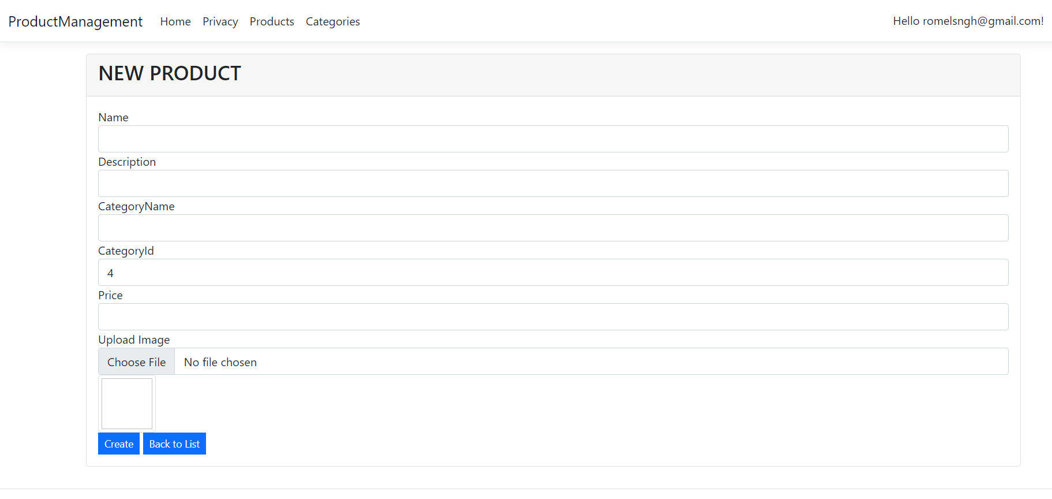

Figure 10 - Create Product

Enter in the relevant information as per the screen above . Clicking on the Choose file button

Will open up a dialog box which will allow you to select and upload an image file for the product. Once all details are updated click on the “Create” button.

**Edit Product :**

This screen looks and behaves very similar to the create product screen. To access this screen

Simply click on the pencil icon illustrated in figure 2.

You will be directed to the Edit Product screen/page , were you can make the necessary changes to the your product. Complete the transaction by clicking on the “Update” button onces done.

**Delete Product :**

If you wish to remove a product from the system you may do so be click on the following icon:

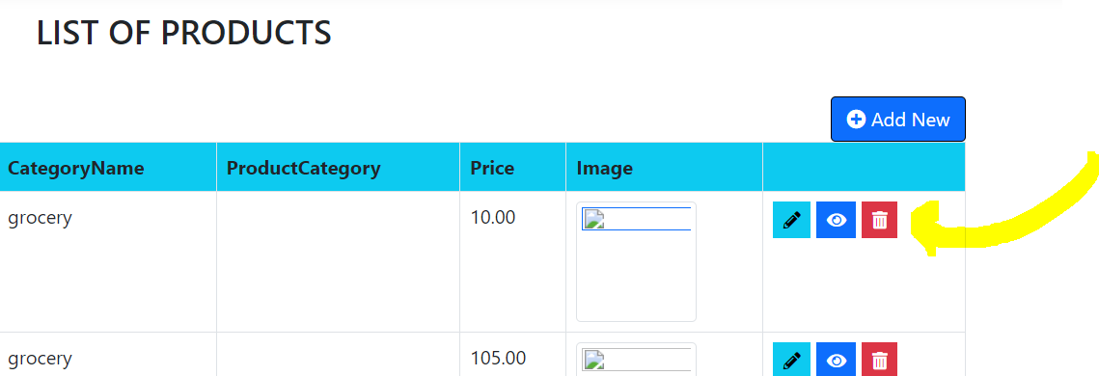

Figure 11 - Delete Button

You will then be directed to the following screen. Clicking on the Delete button will remove the product from the system.

Figure 12- Delete Operation

## Importing Products:

Please refer to figure 1 for the field requirements for the import spreadsheet and figure 2 for the sample spreadsheet.

In order to import new products into the system will a spreadsheet, you may click on the “choose file” button in the screenshot.

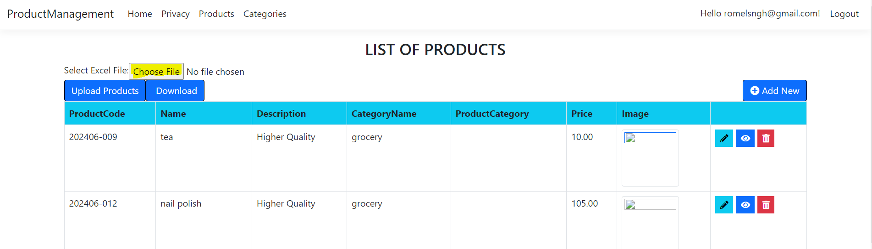

This will open up a dialog box and allow you to search for your excel upload file.

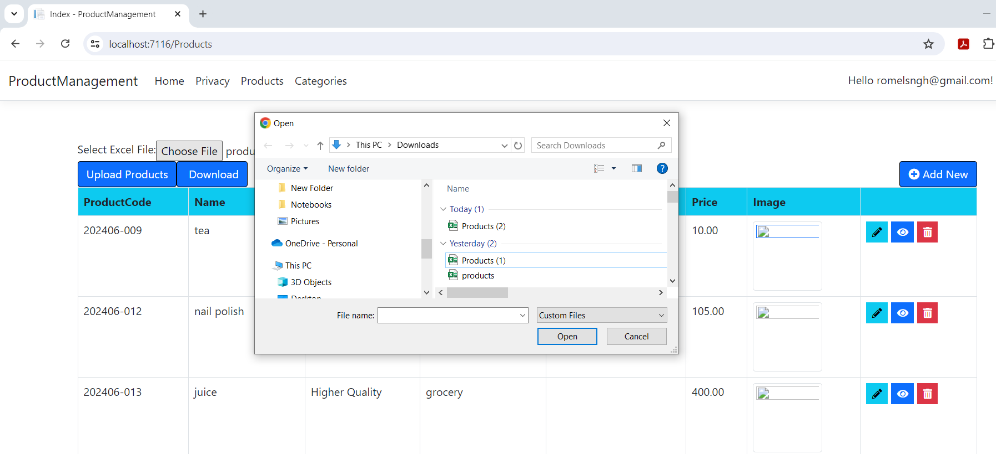

Select your excel file and click on open.

Please note that only excel files with the extension “.xlsx“ are permitted. Using the incorrect format will yield the following error when trying to upload.

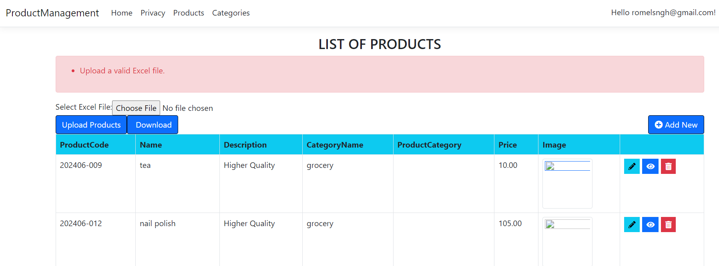

Once the correct format file has been uploaded (and you click on the upload products button) the following message will appear:

